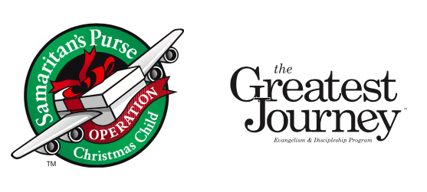

Valley Church Collection Center
Volunteer Sign-up
For National Collection Week
November 13th – 20th, 2017

Activities Center at Valley Church, Cupertino

Mon-Thu 11/13-16 11am-4pm
Fri 11/17 11am-3pm
Sat 11/18 12pm-3pm
Sun 11/19 1pm-5pm
Mon 11/20 12pm-6pm

Valley Church Collection Center
Volunteer Sign-up
For National Collection Week
November 13th – 20th, 2017

Activities Center at Valley Church, Cupertino

Mon-Thu 11/13-16 11am-4pm
Fri 11/17 11am-3pm
Sat 11/18 12pm-3pm
Sun 11/19 1pm-5pm
Mon 11/20 12pm-6pm

We need Packers who will receive, count, and pack the shoebox gifts into the cartons.

We need Loaders who are able to lift and load filled cartons into the truck.

We need Hospitality Team of people who can provide snacks and meals for our volunteers.

*Volunteers under 13 should each have an adult partner.

Thank you for your support and prayers!

For more info, contact occvalley@gmail.com

We need Packers who will receive, count, and pack the shoebox gifts into the cartons.

We need Loaders who are able to lift and load filled cartons into the truck.

We need Hospitality Team of people who can provide snacks and meals for our volunteers.

*Volunteers under 13 should each have an adult partner.

Thank you for your support and prayers!

For more info, contact occvalley@gmail.com

